Final Project Report

Mathew Zacharias

zacharim@umich.edu

Daniel Martin

daniejma@umich.edu

Overview

This assignment sought to have us use the information gained from assignment 5 to create our own program to collect data from the Arduino board provided and interpret/uset it using a python based central program, while also using a peripheral file to set up and run the Arduino board, both relying on methods learned in assignment 5. We sought to create a program that allowed us to take proximity sensor data from the board and use a python program to trigger an alarm message if a boolean variable “alarm_set” was set to “ True “ and the proximity sensor detected an object within the set range defined by two variables “RANGE_NEAR” and “RANGE_FAR”. The user can set the status of the alarm by pressing the ‘a’ key after the program starts to read sensor data, also telling the user of the new alarm status. The user can also use a keyboard interrupt (Ctrl + C) to stop the program, similar to the program from assignment 5.

Setup

The setup for the hardware, the Arduino board, is mainly just running the peripheral and installing the needed libraries if the user’s system does not have them currently installed. The setup for the software involves installing the bleak python library and the keyboard python library. After both steps are completed, all that is needed is to run the program.

Screenshots

Ariduino IDE Compiling and waiting to establish a connection with central (Python).

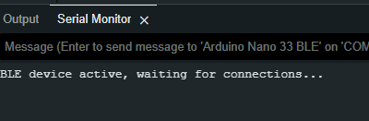

Running the python script:

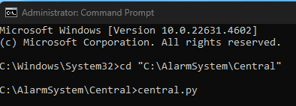

Establishment of connection between Ariduino and Python:

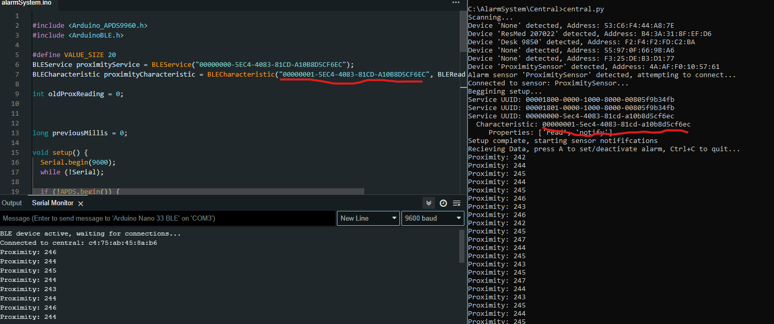

Showcasing alarm system that will output to the user that motion is detected if alarm is turned on:

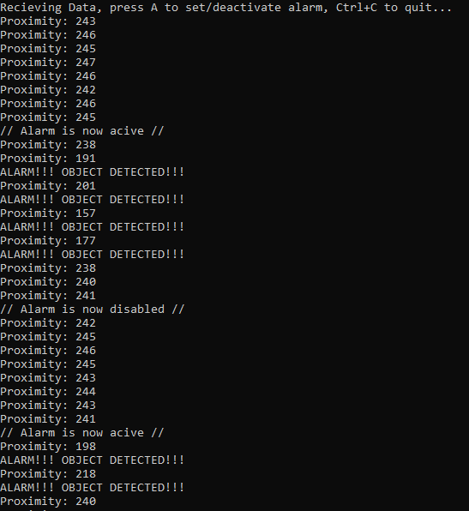

Conclusion/Reflections

This assignment sought to have us use the lessons, methods, and information learned from assignment 5 and use it to create our own version of the program that used the information in a new way. We encountered some issues in implementing the program, such as incorporating new checks for user actions and defining/altering new variables that the program would use to alter these results. In addition neither of us has much experience with python, at least not recently, so we both were working in an unfamiliar coding language. We managed to overcome these issues much like we solve issues in other assignments, re-looking over our code and doing research on possible steps forward. Whether this means installing new code libraries, or moving a piece of code to be held in an already existing recurring piece of code rather than have its own recurring check. Overall, this has helped show us how we can use similar types of code for various different purposes and how we can use different conditions to evaluate the data further to better suit whatever purpose we need.